**Table of Contents**

------------------------------------------------------------------------------------------------------------------------------------------

Install SSL Certificate 2

Assign SSL Certificate 4

Configure SSL Settings 7

# **Install SSL Certificate**

1. On the server where you created the CSR, save the SSL certificate .cer file (e.g., *your_domain_com.cer*) that DigiCert or any other certificate provider sent to you .
2. In the **Windows** start menu, type ***Internet Information Services (IIS) Manager*** and open it.
3. In **Internet Information Services (IIS) Manager**, in the **Connections** menu tree (left pane), locate and click the server name.

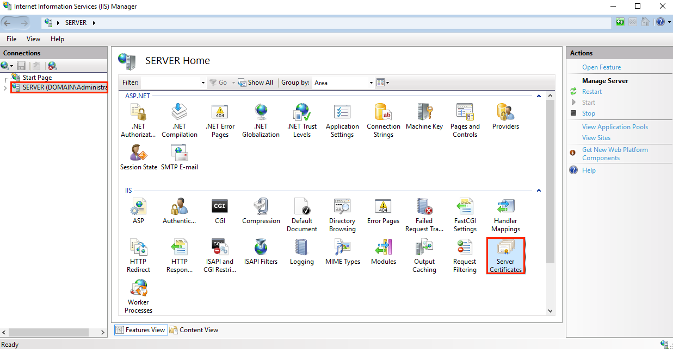

1. On the server name **Home** page (center pane), in the **IIS** section, double-click **Server Certificates**.

1. On the **Server Certificates** page (center pane), in the **Actions** menu (right pane), click the **Complete Certificate Request…** link.

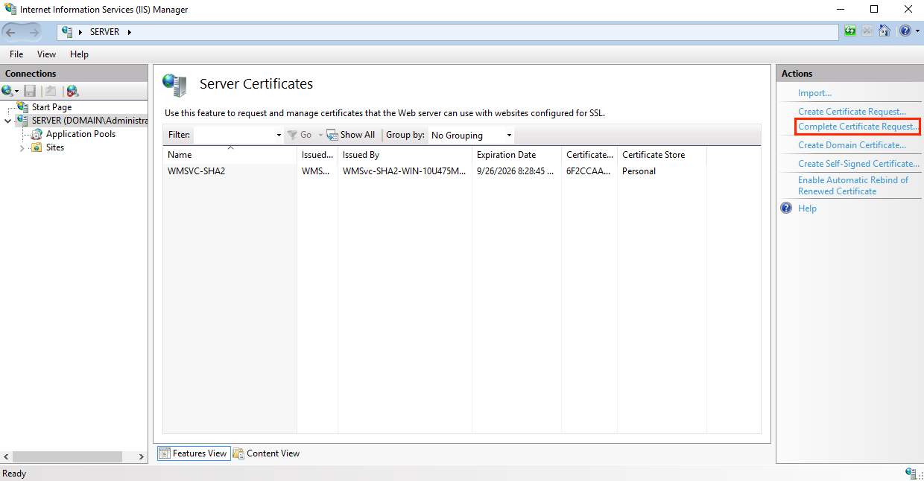

1. In the **Complete Certificate Request** wizard, on the **Specify Certificate Authority Response** page, do the following and then click **OK**:

|  |  |
| --- | --- |
| **File name containing the** | Click the **…** box and browse to and select the .cer file |
| **certificate authority's response:** | (e.g., *your_domain_com.cer*) that DigiCert sent to you. |
|  |  |
| **Friendly name:** | Type a friendly name for the certificate. |
|  | The friendly name is not part of the certificate; instead, it is used to identify the certificate. |
|  | We recommend that you add DigiCert and the expiration date to the end of your friendly name, for example: yoursite-digicert-(expiration date). |
|  | This information helps identify the issuer and expiration date for each certificate. It also helps distinguish multiple certificates with the same domain name. |
|  |  |
| **Select a certificate store** | In the drop-down list, select **Web Hosting**. |
| **for the new certificate:** |  |

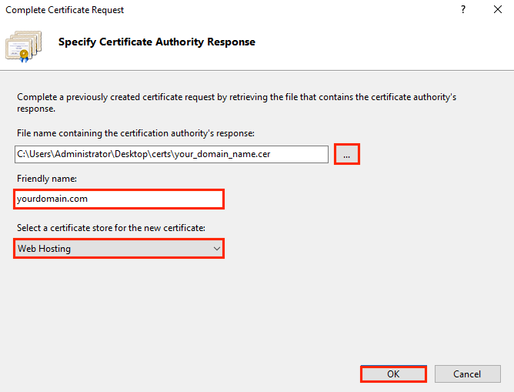

1. Now that you've successfully installed your SSL certificate, you need to assign the certificate to the appropriate site.

# **Assign SSL Certificate**

1. In **Internet Information Services (IIS) Manager**, in the **Connections** menu tree (left pane), expand the name of the server on which the certificate was installed. Then expand **Sites** and click the site you want to use the SSL certificate to secure.

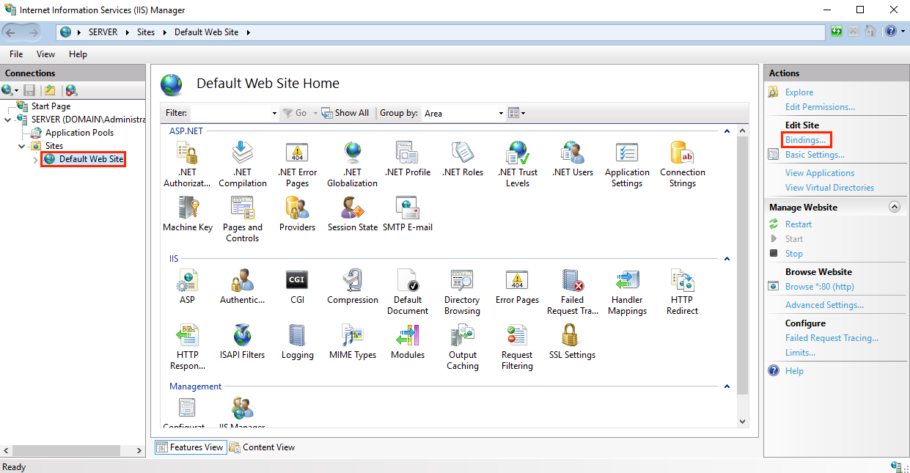

1. On the website **Home** page, in the **Actions** menu (right pane), under **Edit Site**, click the **Bindings…** link.
2. In the **Site Bindings** window, click **Add**.

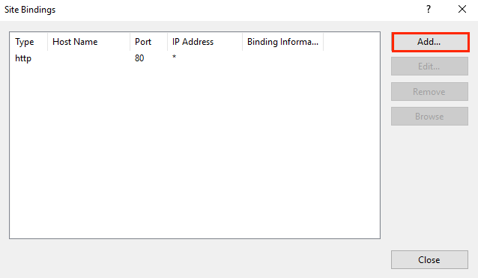

1. In the **Add Site Bindings** window, do the following and then click **OK**:

|  |  |
| --- | --- |
| **Type:** | In the drop-down list, select **https**. |
|  |  |
| **IP address:** | In the drop-down list, select the IP address of the site or select **All Unassigned**. |
|  |  |
| **Port:** | Type port ***443***. The port over which traffic is secure by SSL is port 443. |
|  |  |
| **SSL certificate:** | In the drop-down list, select your new SSL certificate (e.g., *yourdomain.com*). |

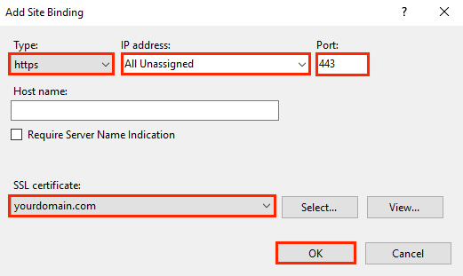

1. Your SSL certificate is now installed, and the website configured to accept secure connections.

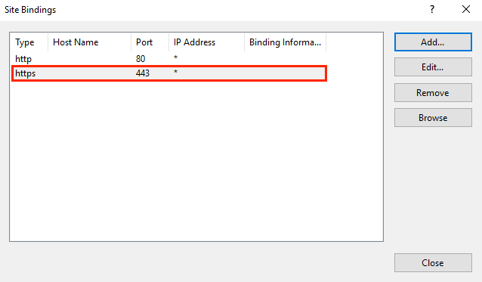

# **Configure SSL Settings**

Configure SSL settings if you want your site to require SSL, or to interact in a specific way with client certificates. Click the site node in the tree view to go back to the site's home page. Double-click the **SSL Settings** feature in the middle pane.

